A document describing how you implemented each major feature. For each feature, you shall include several possible solutions, physical or implementation limitations, as well as your actual solution (which programming language, platform, APIs, etc.).

How the Website was Developed

The website uses HTML to display content, css to stylize the content and PHP to access and manage the website's database.

There are four types of articles, assignment advice, practice problems, programming issues and topics. Each type of article has a home page where the articles are listed by difficulty. The only exception is assignment advice does not have articles listed by difficulty. Each type of article also has a view page, where specific articles can be viewed. Articles are accessed within the database by their ID, with each type of article having its own table and each article possessing its own unique ID within its corresponding table.

How to run the Website

The website is run on localhost. DB.php contains the database login information. CSHELP.sql contains the database and needs to be installed on the computer to run.

Comparing Project to Requirements

1. Provide answers for how to handle programming issues.

The system explains how to handle programming issues effectively. The descriptions also provide information on how to avoid the issues in the first place.

2. Provide templates for starting and breaking down assignments

The steps for dividing assignments are outlined in the assignment advice part of the website.

3. Provide information on commonly used language features.

Currently there is only information on Python's commonly used language features.

4. Display why learning certain skills is important.

Currently, there is not information on why learning certain skills is important. That information can be added in the future. Also, with topics being for review rather than an introduction, providing motivation is less important.

5. Offer learning scenarios that allow for learning by doing.

Users can compile code on the website to solve problems, which allows for learning by doing.

6. Offer visuals that show how code works.

There are currently not any visuals displaying how coding works, but visuals can be added in the future.

7. Allow for searching for key information with a search bar

Articles can be searched for with a search bar. The results are also sorted by the type of article, such as topic, assignment advice, practice problem and programming issue.

8. Link to other useful websites for learning programming

Links to other websites are provided and there is a description displayed for each link.

9. The Design is easy to use and effective

The website's structure is quite consistent, making the website easy to use and effective.

Major Features

General Design

Possible Solutions:

There were minimal modifications made from the chosen prototype. Implementation was based around the combined prototypes. I only had the search bar on the right bar, which did not use the right bar efficiently.

Implementation:

I used databases to avoid making dozens of pages. There is only one page for each type of article, with the corresponding descriptions and Tutorialspoint links stored in a database. The ID parameter is used to access a specific article. The versatile nature of the system allows for more consistent design across the board. Adding the key links to the right bar made it much more efficient.

Assignment Advice

Possible Solutions:

I originally planned on showing advice.

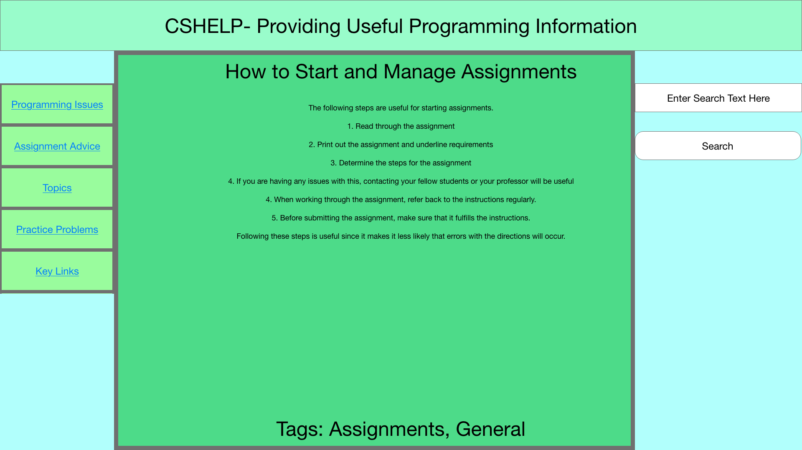

Implementation:

Assignment advice offers advice primarily on how to handle assignments in general rather than specific types of assignments. While assignment advice is currently limited in scope, it can be expanded to include more assignments.

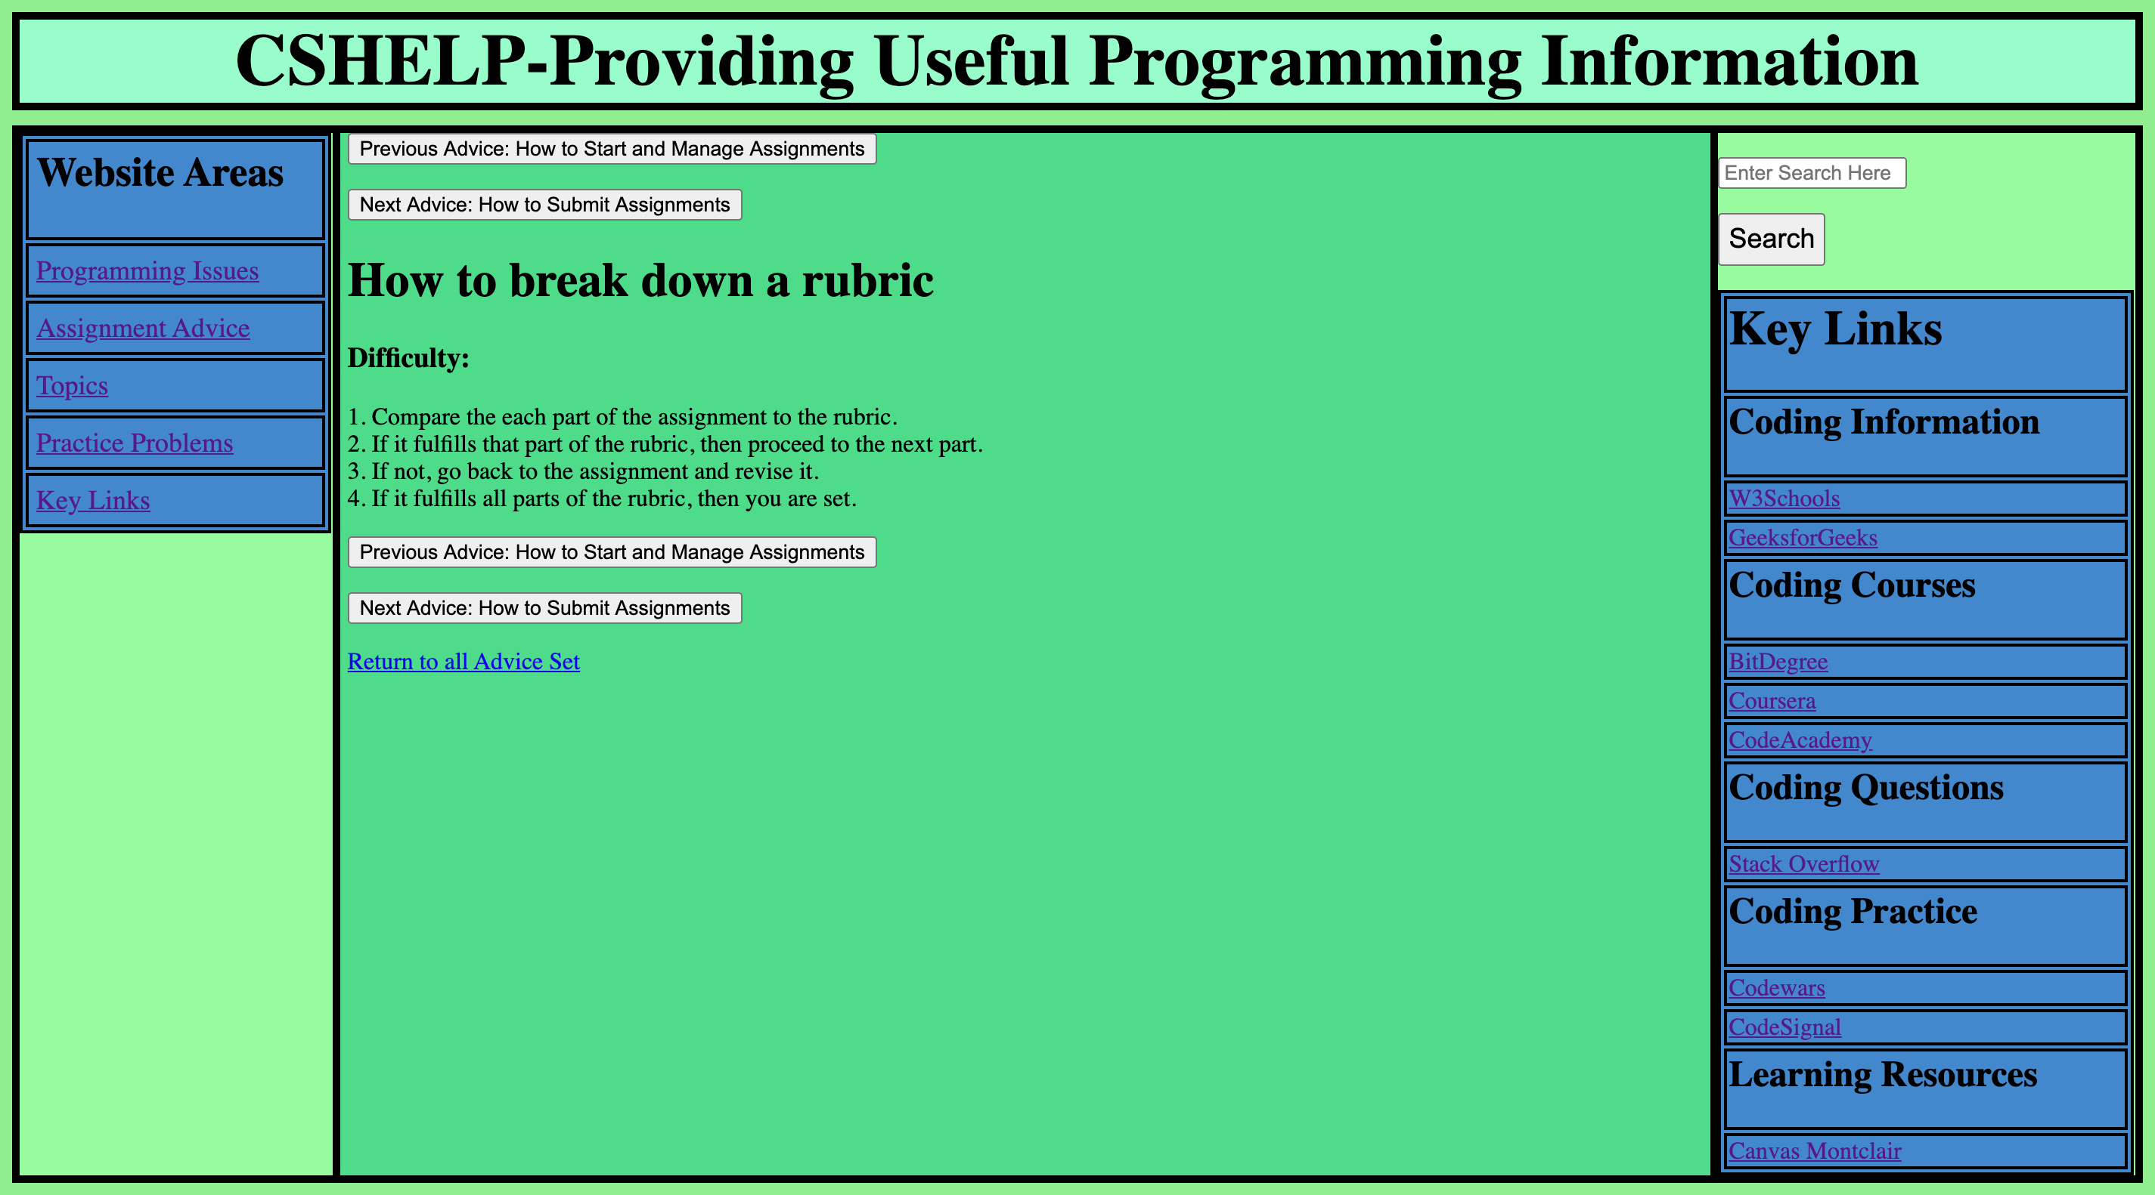

Practice Problems

Possible Solutions:

The initial plan for practice problems was to have users work on the problem on their own device.

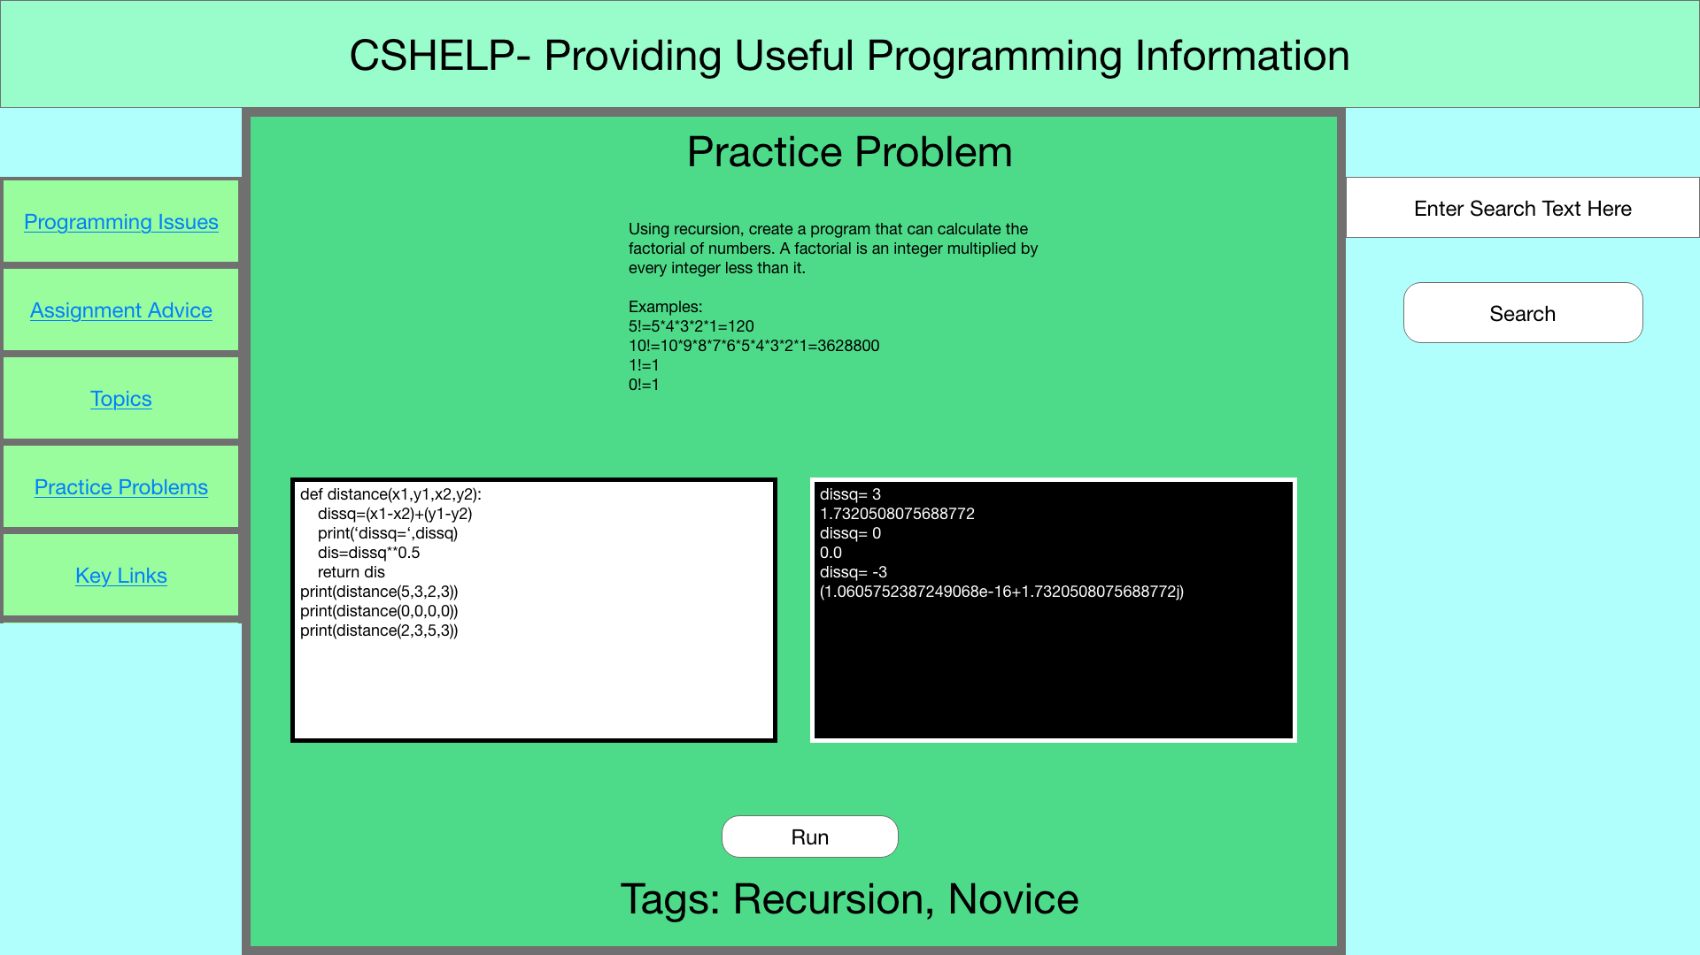

Implementation:

The implementation now embeds a coding editor from tutorialspoint, so users can work on the problems while seeing the solutions in front of them. Instead, I used Tutorialspoint to set up an initial starting point for the problem. While Tutorialspoint typically offers a blank compiler, I created files for each problem that allow users to start coding with the functions defined. In addition, I added expected results, sets of inputs and outputs that will occur when the problem is solved, so users know their program is working. By providing ways of practicing, this system allows for more interaction and learning.

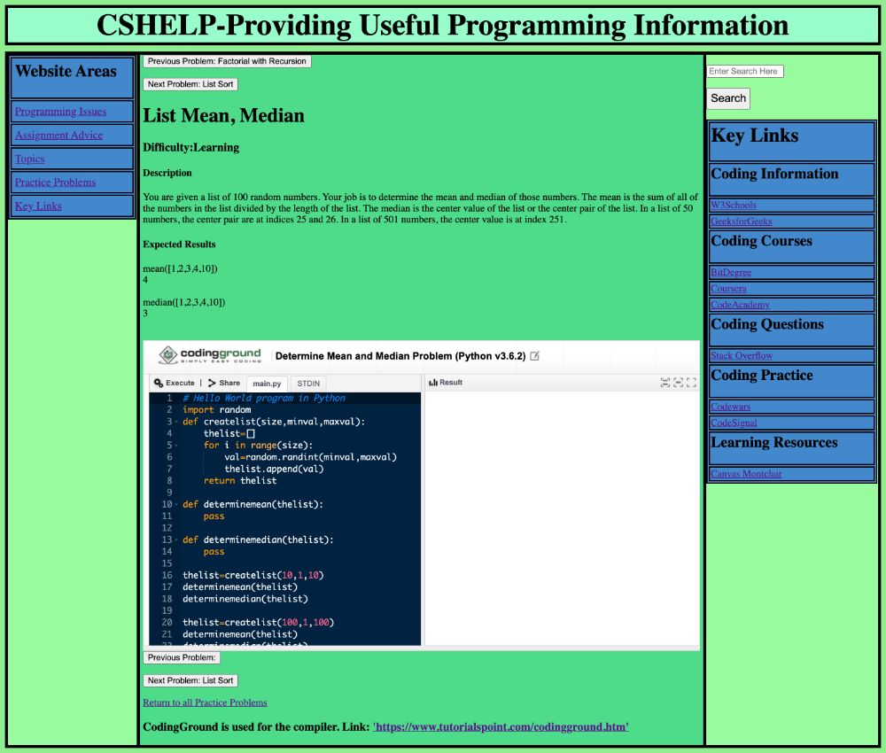

Programming Issues

Possible Solutions:

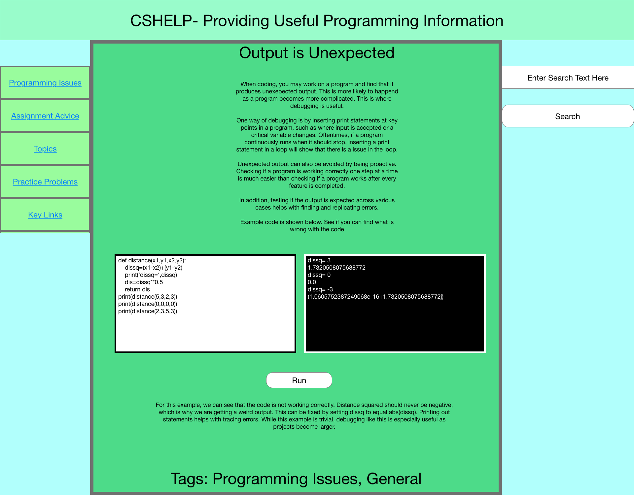

I originally planned on adding a more flexible structure where the compiler can be placed anywhere within the article. In addition, I planned on adding code demonstrations to programming issues.

Implementation:

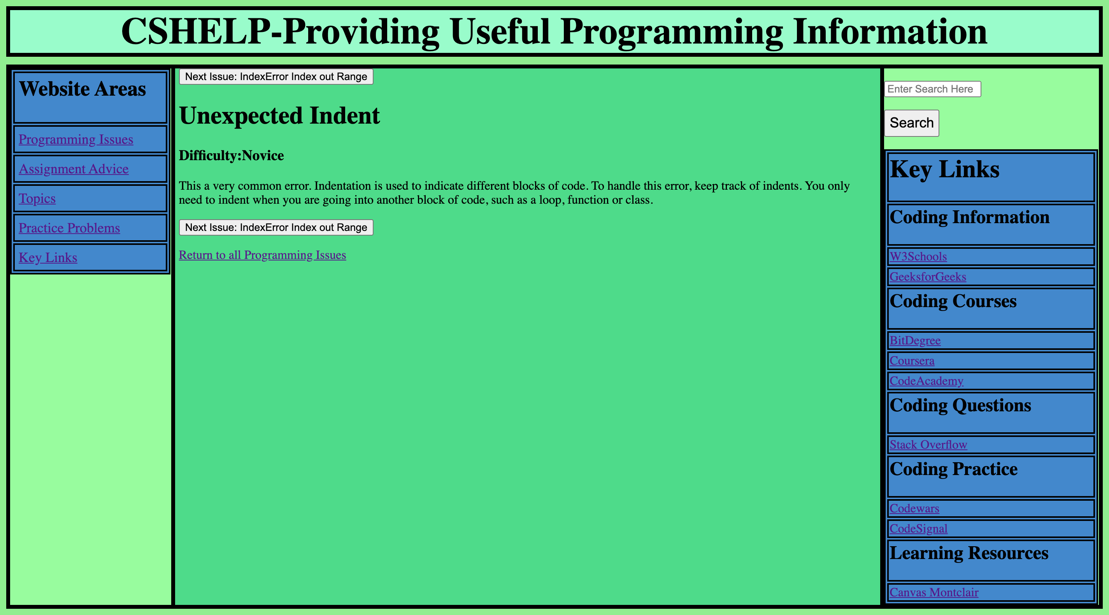

Programming issues currently do not have demonstrations of the issues. That is a feature that can be added with a bit more time.

Topics

Possible Solutions:

My original plan was to thoroughly describe each topic, so users could learn about the topic without having seen it before. Offering full tutorials for different computer science topics would take far too long, and is better done by other websites, such as w3schools. I instead decided to add simple review for each topic. This is helpful for preparing for final exams or getting a quick refresher.

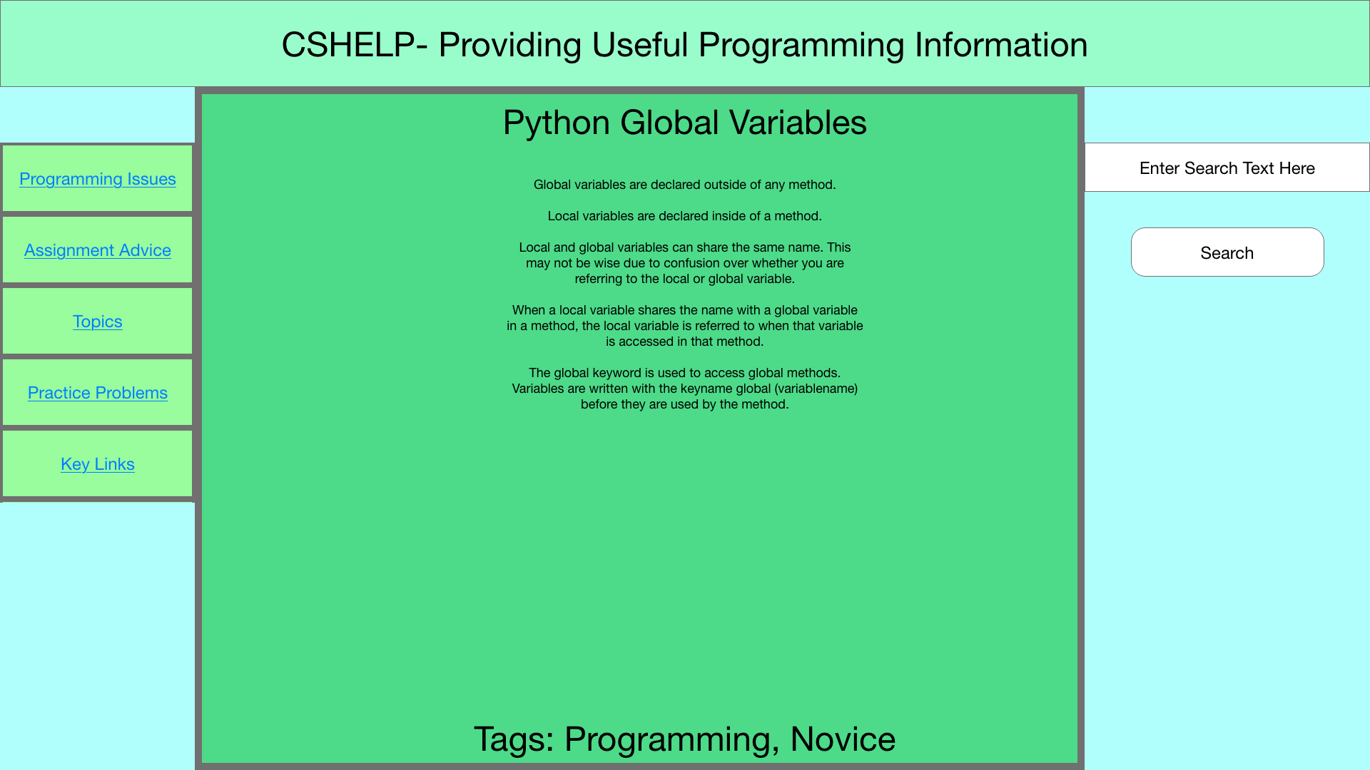

Implementation:

I instead decided to add simple review for each topic. This is helpful for preparing for final exams or getting a quick refresher. While this does not help with learning the topic, it makes review very easy while preventing excessive effort from going into writing about topics.

In addition, I originally planned on only having static text for each topic. I added code in order to demonstrate how each topic works where applicable and added non-coding topics, such as decimal to binary.

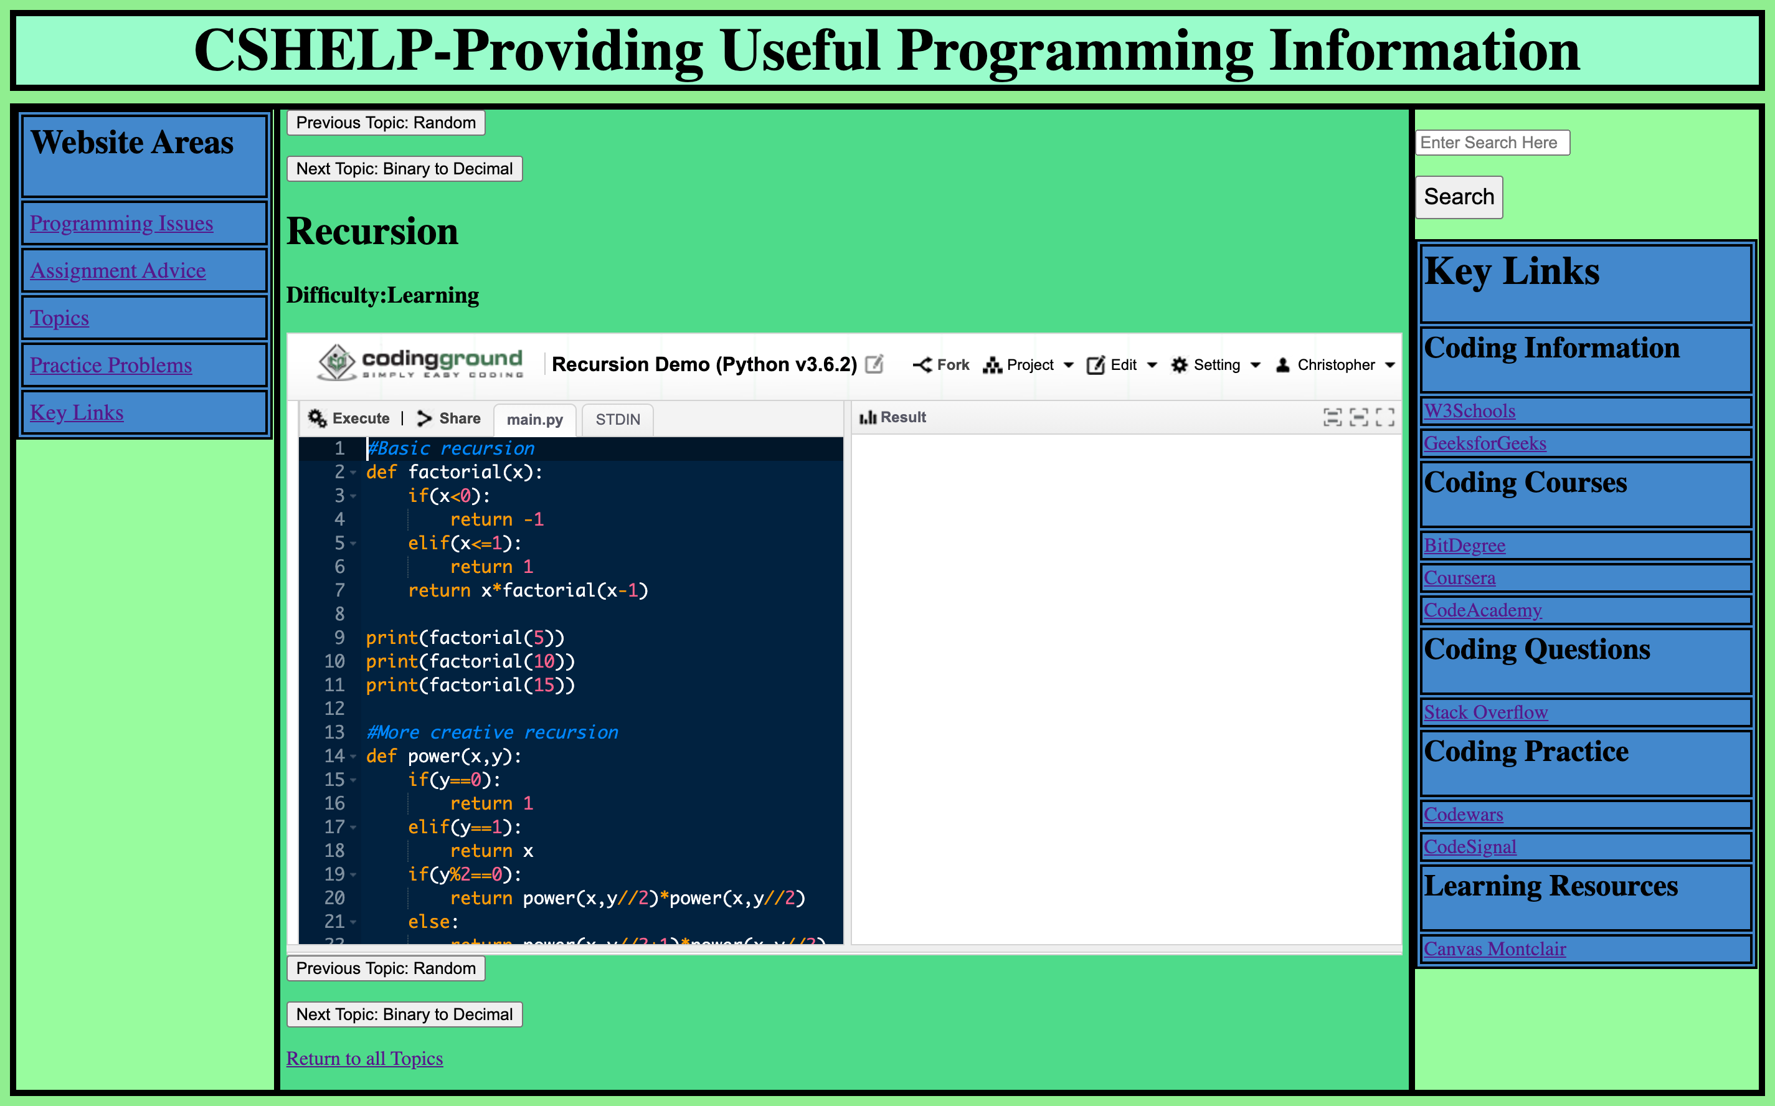

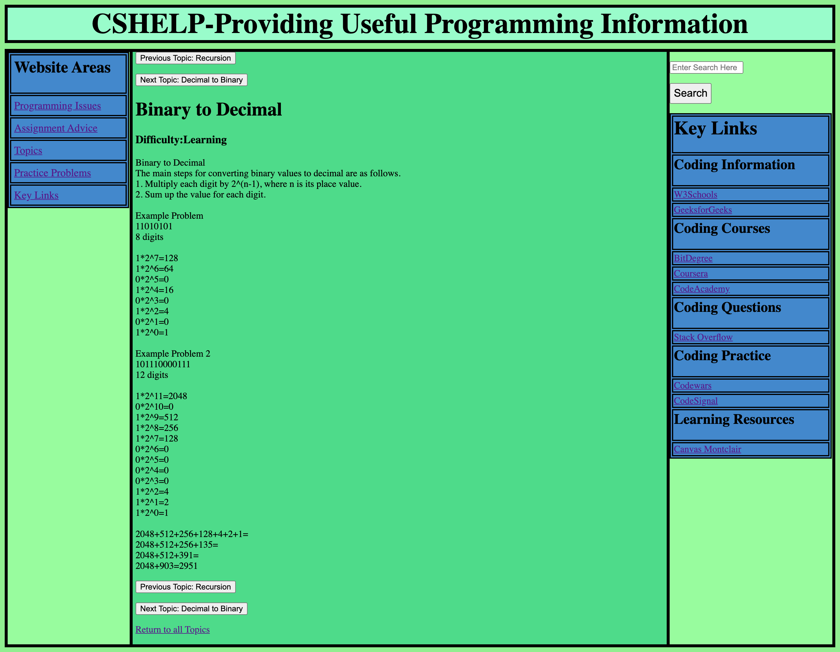

Key Links

Possible Solutions:

I initially designed the key links without descriptions. The key links were only categorized.

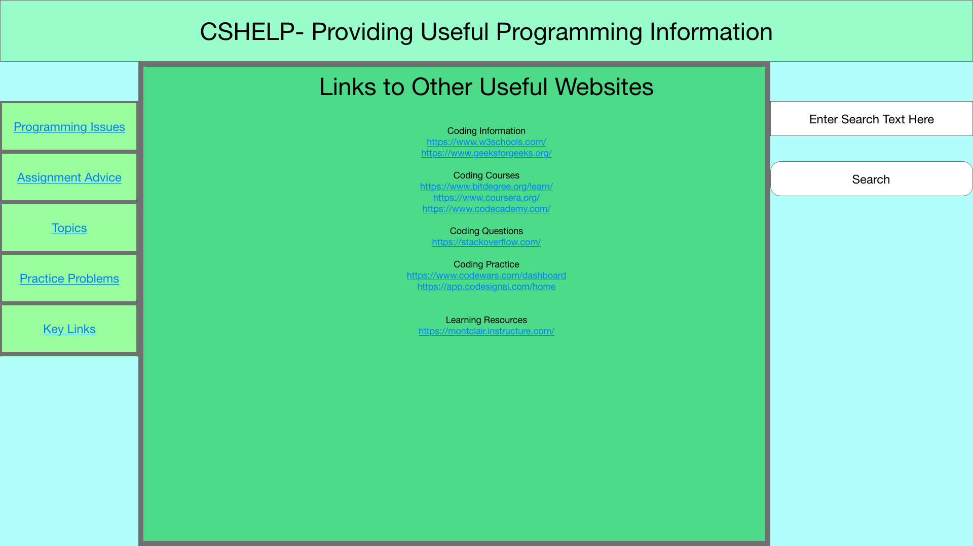

Implementation:

I decided to add descriptions for the key links and to have them always be visible on the right side bar while on the website. The descriptions make users more inclined to visit the listed websites.

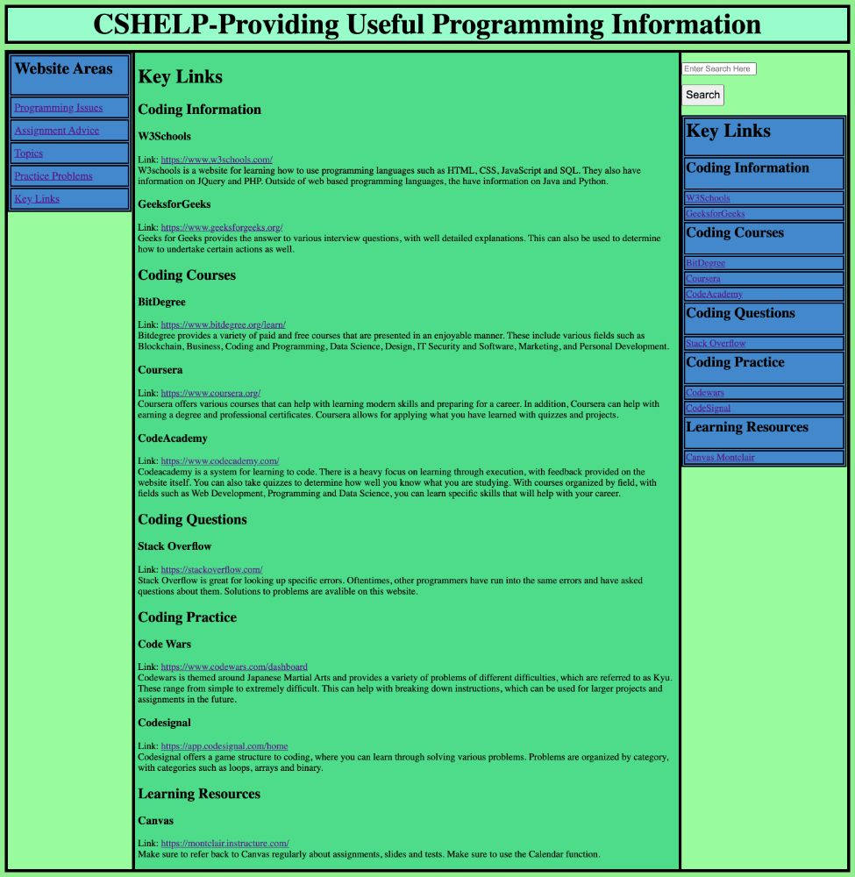

Search

Possible Solutions:

I was initially unsure as to how the search would be implemented. I originally planned on search working across one table only, which I have done before.

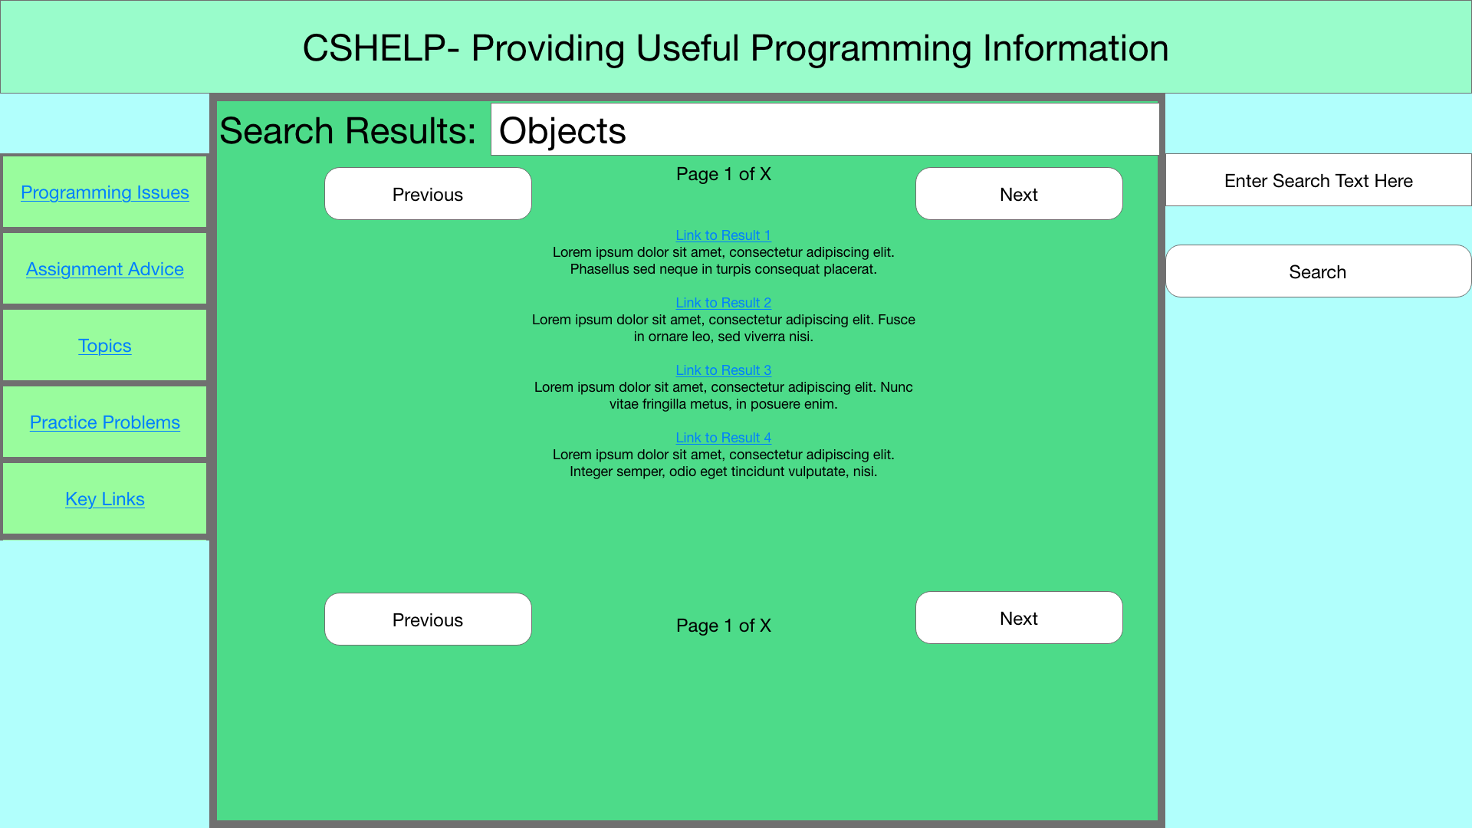

Implementation:

When implementing search, the system uses multiple tables and sorts the search results based on the table the article is from.

